LAB

REPORT

CSE 114 : Data Structure and Algorithms Sessional

|  |  |
| --- | --- |
| PREPARED BY  Mehrin Farzana  ID: 2101013  Session: 2021-2022  Date: 03/08/2023 | SUPERVISED BY  Suman Saha  Lecturer  Department of IRE, BDU |

|  |  |
| --- | --- |
| logo1 | BANGABANDHU SHEIKH MUJIBUR RAHMAN DIGITAL UNIVERSITY  (BDU) |
|  |  |

**List of Problems**

1. Given the following-

• A knapsack (kind of shoulder bag) with limited weight capacity.

• Few items each having some weight and value.

The problem states,

Which items should be placed into the knapsack such that-

• The value or profit obtained by putting the items into the knapsack is maximum.

• And the weight limit of the knapsack does not exceed.

1. Given n number of activities, their start time and and time, find the maximum number of activities that can be performed without collision.

**Problem No.:** 01

**Problem Statement:**

Given the following-

• A knapsack (kind of shoulder bag) with limited weight capacity.

• Few items each having some weight and value.

The problem states,

Which items should be placed into the knapsack such that-

• The value or profit obtained by putting the items into the knapsack is maximum.

• And the weight limit of the knapsack does not exceed.

**Code:**

#include <stdio.h>

int main()

{

int n;

float m, kp=0, kw=0;

scanf("%d%f", &n, &m);

float p[n], w[n], a[n];

for(int i=0; i<n; i++)

scanf("%f", &p[i]);

for(int i=0; i<n; i++)

scanf("%f", &w[i]);

for(int i=0; i<n; i++)

a[i]=p[i]/w[i];

for(int i=0; i<n-1; i++){

for(int j=0; j<n-i-1; j++){

if(a[j]<a[j+1]){

float tmp=p[j];

p[j]=p[j+1];

p[j+1]=tmp;

tmp=w[j];

w[j]=w[j+1];

w[j+1]=tmp;

}

}

}

for(int i=0; i<n; i++){

if((kw+w[i])>=m){

kp+=p[i]*((m-kw)/w[i]);

kw+=((m-kw)/w[i])*w[i];

break;

}

else if((kw+w[i])<m){

kw+=w[i];

kp+=p[i];

}

}

printf("%f\n", kp);

return 0;

}

**Output:**

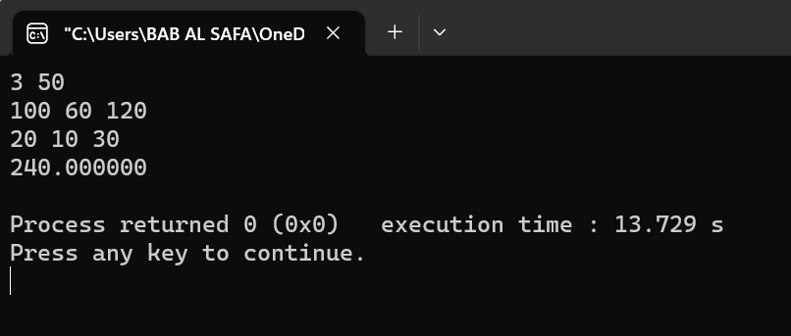

Fig 1.1: Output on console for case 1.

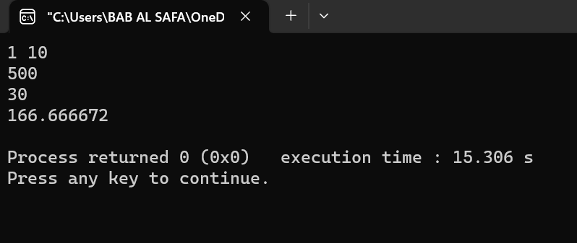

Fig 1.2: Output on console for case 2.

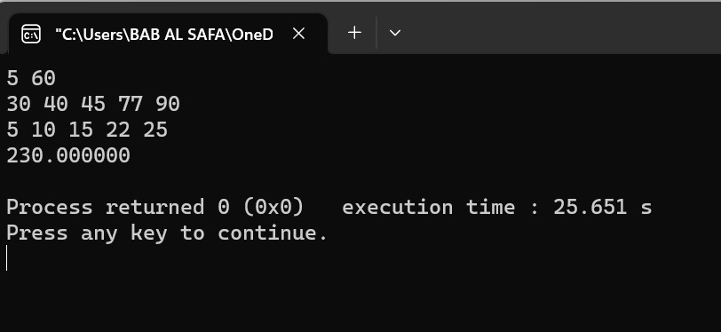

Fig 1.3: Output on console for case 3.

**Problem No.:** 02

**Problem Statement:**

Given n number of activities, their start time and and time, find the maximum number of activities that can be performed without collision.

**Code:**

#include <stdio.h>

int main()

{

int n,x;

scanf("%d", &n);

int a[n][2];

for(int i=0; i<n; i++){

printf("Enter start time and end time of %d activity\n", i+1);

scanf("%d%d", &a[i][0], &a[i][1]);

}

for(int i=0; i<n-1; i++){

for(int j=0; j<n-i-1; j++){

if(a[j][1]>a[j+1][1]){

int tmp = a[j][1];

a[j][1] = a[j+1][1];

a[j+1][1] = tmp;

tmp = a[j][0];

a[j][0] = a[j+1][0];

a[j+1][0] = tmp;

}

}

}

printf("Following activities are selected:\n");

printf("(%d, %d)\n", a[0][0], a[0][1]);

x=a[0][1];

for(int i=1; i<n; i++){

if(a[i][0]>x){

x=a[i][1];

printf("(%d, %d)", a[i][0], a[i][1]);

printf("\n");

}

}

return 0;

}

**Output:**

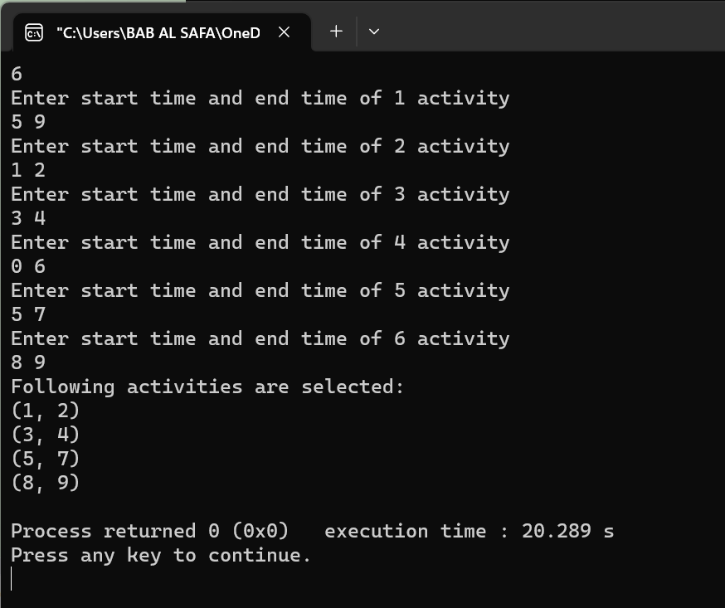

Fig 2.1: Output on console for case 1.

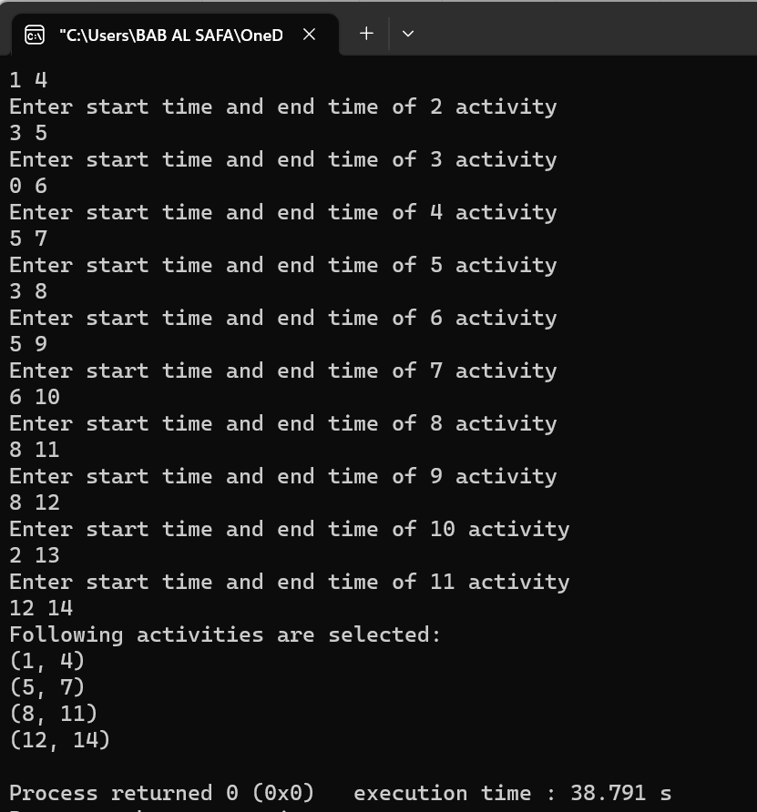

Fig 2.2: Output on console for case 2.